Trong HomeAdminController:

[Route("SuaCauThu")]

[HttpGet]

public IActionResult SuaCauThu(string cauthuId)

{

ViewBag.CauLacBoId = new SelectList(csdl.Caulacbos.ToList(), "CauLacBoId", "TenClb");

var cauthu = csdl.Cauthus.Find(cauthuId);

return View(cauthu);

}

[Route("SuaCauThu")]

[HttpPost]

[ValidateAntiForgeryToken]

public IActionResult SuaCauThu(Cauthu cauthu)

{

if (ModelState.IsValid)

{

csdl.Entry(cauthu).State = EntityState.Modified;

csdl.SaveChanges();

return RedirectToAction("Index", "Home");

}

return View(cauthu);

}

Add view -> Razor View -> Edit -> CauThu

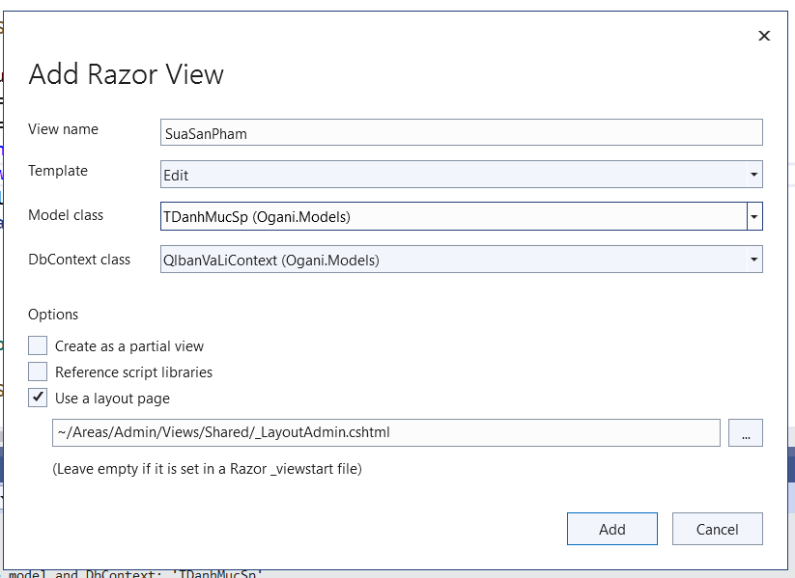

@model KtraLan2.Models.Cauthu

@addTagHelper *, Microsoft.AspNetCore.Mvc.TagHelpers

Them: @addTagHelper *, Microsoft.AspNetCore.Mvc.TagHelpers

Va method=”post”

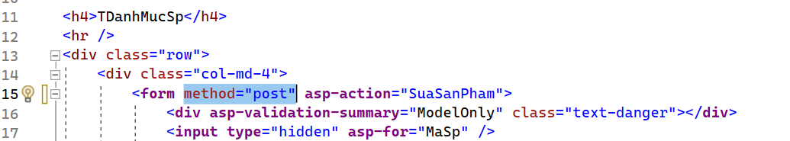

Tìm thẻ a muốn add link SuaCauThu (ở đây là trang index)

<**a** **asp-action**="SuaCauThu" **asp-route-cauthuId**="@item.CauThuId" class="place__btn bg__color--berlin">Sửa</**a**>

